Camp Cachalot

38th Annual Klondike Derby

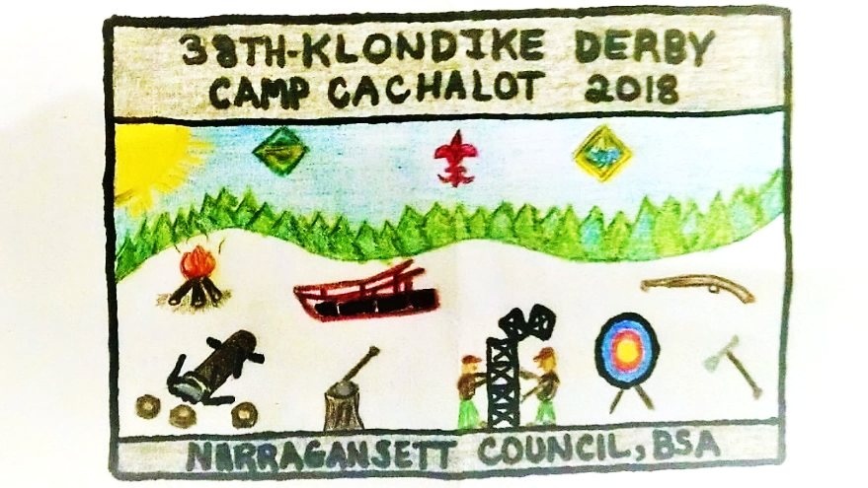
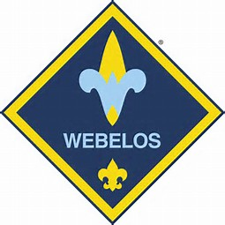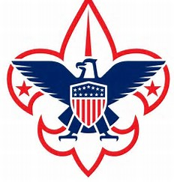
Camp Cachalot
Camp Cachalot
January 20, 2018

NEW

*SENIOR/ VENTURE* DIVISION

Many New Changes and
New Stations as of “2018”

Check entire packet
for changes

Venturers are not required to have
Firem’n chit or Totin’ Chip
(nugget count will not be penalized)

I. General Information

A. What is a Klondike Derby?
A Klondike derby is a one day competitive event which uses sledges and Klondike Gold Rush themes to complete a multiple “Town” course and sledge race, pitting each team’s skills and team work against the clock. The purposes of the derby are: first a grand outdoor winter adventure full of fun and surprises, and second, a way for Scouts to test their basic camping and survival skills.

Only in case of extreme bad weather will the derby
be postponed or cancelled.

Each Webelos Den/Boy Scout Troop/Venture Crew is encouraged to enter as many expedition teams as they can support. The minimum team size is 4 Scouts; smaller teams will be combined so that all may participate. Maximum team size is 8 Scouts. Each expedition will visit several “Towns”. The order of the towns must be followed using the map provided. Each of these towns will have a Mayor and a minimum of two judges. The Mayor of the town can be identified by his orange “Mayor” stocking hat. The Scouts will have a task to complete and will be scored on proper technique, team work, and Scout spirit.

The Mayor’s word on all matters is final.
The Patrol Leader is the only member of the team that may communicate with the Mayor or Judges of the town.
THIS EVENT IS FOR SCOUTS ONLY.
ADULTS ARE REQUESTED NOT TO ASSIST THE PATROLS AND WILL NOT BE ALLOWED IN THE TOWNS. A MAYOR OF A TOWN WILL BE ALLOWED TO DEDUCT (25) NUGGETS AS A PENALTY IF HE SEES ADULTS INTERFERING.
Have your Scouts refrain from bringing cell phones or other electronic devices to the Klondike Derby.
NO SNOWBALLS
B. Inspection and Weigh-in Procedures
Each patrol will begin with a sledge inspection and weigh-in at The Outfitters (Boat
House) field beginning at 7:00 AM until 8:30 AM. All sledges will be checked to insure all weight and dimension requirements are met and all equipment is present. Wheels are not allowed on the sledge.
The team will also be checked for proper dress for the day’s activities and the current expected weather conditions.

If the Klondike committee feels a Scout is not dressed properly for conditions he will not be allowed to compete. In this case a team will be allowed to compete with three members.

Each Scout must have:
- A stocking hat or hat with ear protection. (Baseball cap style hats will be allowed if the temperature is above freezing).
- Gloves or mittens.
- Proper footwear for conditions. Absolutely no sneakers allowed during the day’s activities
- A complete change of clothes.
- Rain Gear (must be a jacket or poncho).
Any team meeting all of the requirements at this station will be awarded a bonus of 15 nuggets. If a patrol does not meet the requirements they will be penalized at the end of the day’s activities with a deduction of (15) nuggets.

Empty sledges will be weighed and must weigh a minimum of 50lbs.
One bonus nugget will be subtracted for every 5 lbs. under weight. A team with an underweight sledge must add weight to bring the sledge’s weight to 50 lbs. A note will be added to the score sheet of such and Town Mayors will check that the weight is in the sledge. At any time during the day a staff or committee member can check sledges for proper equipment.
C. Check In
After weigh in at The Outfitters (Boat House) Field, patrols will then proceed to Dawson City (The 21 Club). Only the patrol leader is allowed to enter and register their patrol. He must bring a nugget pouch, waterproof map holder, Klondike Derby Sledge Registration form completely filled out and signed by the Scoutmaster. Please be sure you have written your Service Area in the appropriate place. Teams whose average age is 14 or more will compete in the Senior Division. Teams with an average age of 13.9 or younger will complete in the Scout Division.
Each patrol leader will be issued any last minute instructions, an official map, scavenger hunt paper, and a score sheet. If your team makes no effort to do the compass course or the scavenger hunt, you will be given a zero for those events.

By participating in the Compass Course (both Boy Scouts and WEBELOS) and the Scavenger Hunt, the points awarded from these events can make a difference in the final scoring.

After check in, each patrol will proceed to the Yukon Territory (Tom Cullen Field) for their assigned starting time. At 15 minute intervals, the starter will send off 10 patrols into the vast tundra in search of Klondike Gold. Each team must follow the map issued at registration.
If a team arrives at a town out of order they will receive ½ the nuggets they would have received had they arrived in the proper order. They will be instructed to go to the proper town and complete the task at that town before being able to complete the task at town they arrived in out of order.
Upon the completion of the last town of the day, the patrol leader and a buddy must report to the official scoring station at Dawson City (The 21 Club) with their score sheet and nugget pouch, then return to Yukon Territory (Tom Cullen Field) for the “Great Race”. All scores will be tabulated, checked and announced at the end of the day at approximately 5:30PM at Dawson City (The 21 Club).

Only the Patrol Leader and the SM will be allowed in the scoring area. Once the patrol leader submits the score sheet he will rejoin his patrol for the Great Race.
D. Awards
Trophy and plaques will be awarded to the first-place teams in the Scout Division, Senior Division and WEBELOS Division
Plaques will be awarded to the second & third place finishers in each division and they will be awarded at a round table following the derby.

E. Equipment to be carried on the sledge
- Patrol Leader arm band (Must have “PL” on it).
- Nugget Pouch
- Notebook or clipboard & method to keep score sheet dry & neat.
- Rain Gear for each team member (must be a jacket or poncho).
- One (6ft) length 1/4 diameter rope per Scout.
EE. Senior/Venture will need 8pc. of rope, minimum 6ft. long.
- Hard hat, or bicycle helmet for each Scout.
- Two compasses and a pace counter for each team member.
- One hot cup for each team member.
- Cooking kit & utensils for each Scout.
- Walking stick (Stave) for each Scout.
JJ. Senior/Venture will need 8pc. of staves, minimum 6ft. long.
- One complete change of clothes for each team member.
- (2) Unopened packaged hand warmers per Scout.
- Patrol Flag.
- One Boy Scout /Webelos Scout handbook per team.
- Flint and steel.
- One (20ft) length of ¼ diameter rope.
- One steel trash can cover or similar to put hot coals in for cooking lunch
- First aid kit (must contain recommended equipment for Patrol/Webelos Den/Boy Scout Troop/Venture Crew from Boy Scout hand book page.)
- One 20 x 20 tarp, the tarp can be larger.
- Two warm blankets.
- One pre-made rescue line.
- Roll of toilet paper.
- Two clean (NO PAINT OR OIL) #10 can with wire handle.
- Dish soap, and sponge.
- Oven mitts or cooking gloves.
- Trash bag for rubbish.

F. Scoutmasters Notes
Scoutmasters or their representative should make every attempt to attend the Klondike Derby pre-meeting. This is where information is shared and any questions or concerns are answered.

Each unit participating will be asked to provide a minimum of two adults to man the Klondike towns in order to have a successful day.

Last year’s winner please bring the trophy by the Scout shop, the office or bring it to the December Round Table.
Mayors must check in with the Governor in at Dawson City (The 21 Club) before going to your town. All stations must be manned by 8:00AM.

II. Official Klondike Derby Regulations
The following regulations are in place to ensure a safe and enjoyable event. Please follow directions, and respect other individuals competing in the days’ events.
A. All walking sticks are for walking and to be used as tools where they will be needed. They may be stored on the sledges until they are needed or a Scout may use them to assist in walking the course throughout the day. Patrols or Scouts caught swinging sticks, WILL lose 25 nuggets and a warning will be issued. In the event a second warning is issued the patrol will be dismissed from the event.
B. Each Webelos Den/Boy Scout Troop/Venture Crew is required to have at least two adults serve on the Klondike staff in some capacity (Mayor, Scorer, Judge, etc.)
C. Each patrol must have between four and eight members to compete, smaller groups will be combined and larger groups will be split up. (The exception to this rule is when a team loses a team member due to a Scout not being dressed properly. (See section 1B par. 2 above)
D. Each Scout must be dressed appropriately for the days’ weather conditions.
E. Each unit must submit a roster for each team signed in by the patrol leader at the time of check-in.

F. Each Team must turn in a copy of their menu for lunch at the time of check-in.
G. NO TEAM will be allowed to begin before 8:30AM or after 12PM, From Dawson City (21 Club) sledges are to gather in Yukon Territory (Tom Cullen Field) and a sound will signal from Yukon Territory (Tom Cullen Field), An adult will announce when to start!
H. Adults will not be allowed to physically help, aid verbally, or assist in anyway, with any team during the days’ events including lunch. WEBELOS Leaders and/or Den Chiefs may assist a WEBELOS Sledge at the Valley Forge cooking station.

Mayors, Judges, Scorers, or committee members may deduct up to ½ the nuggets earned at that Town.

I. Any injured or ill Scout or Scouter must present himself to the Klondike medical staff located at the Handicraft Post.
J. The registration fee for each Scout and Scouter is $10.00. A Scout dismissed because of behavior and or lack of proper clothing will not be entitled to any refund.
K. Each patrol leader must wear an arm band displaying the letters “PL”
L. Five-Mile pond and all other bodies of water are entirely off limits to everyone in camp, including staff and unit leaders. This rule is in effect whether the ponds are frozen or not. This includes throwing rocks, sticks or other objects. Any team or individual not in compliance may be disqualified.

M. Sledge Inspection
- Each sledge must be six feet long
- Each sledge must display a patrol flag
- Each sledge must weigh 50lbs when empty. Nuggets will be deducted for underweight sledges and weight must be added to come up to the 50lbs. Any weight added must be secured and remain on the sledge until the completion of the great race.

Schedule Of Events

7:00-8:30 Weigh-in & Sledge inspection at The Outfitters (Boat House).
7:30-8:30 Registration at Dawson City (The 21 Club)
8:30 Patrols started at Yukon Territory (Tom Cullen Field)
8:45-12:00 Klondike Underway
1200-1:00 Lunch
1:00-3:45 Klondike Underway
4:00-4:30 Great Race @ Yukon Field (Tom Cullen Field)
4:45-5:30 Race Results @ Dawson City (The 21 Club)

IV. Special Notes, Reminders & Changes
Please note that any station outlined below may be changed without notice due to staffing requirements.
PER THE CAMP RANGER; only above ground fires will be allowed. All fires in towns without a fire pit shall be in a half barrel. Let the fire burn itself out, do not put the fire out. Make sure the fire has burned down before leaving. Leave the ashes in the half barrel and do not empty the ashes in the site or in the woods. The Ranger will empty and properly dispose of the ashes in the barrels or containers.
Some picnic tables will be available. If you move a table please return it to its original location when done.

ABSOLUTELY NO VEHICLES OR TRAILERS WILL BE ALLOWED TO STAY IN THE KLONDIKE ACTIVITY AREA. ALL VEHICLES AND TRAILERS MUST BE RETURNED TO THE PARKING AREA BY 6:45 AM.
No MRE’S will be allowed for the Cooking Town. Judging for lunch will be based on preparation, organization, cooking skills, clean up and the percentage of Scouts with Fireman Chit or Outdoorsman badge.
During lunch only one town will remain active, that town will be Valley Forge. Any mayor, staff member or committee member not helping at Valley Forge can eat a hot lunch; have a warm drink or just warm up at Dawson City (The 21 Club).
V. Towns and their Tasks—All Divisions

1. Cheechaku - Shelter Set-Up
Location – Sconticut (Site 3N)
Task: There’s a major storm coming that’s going to last a day or two. Utilizing the equipment on your sledge, you must build a sturdy shelter to keep your team safe until the storm passes. Your shelter must fit your patrol, sledge and remaining gear.

**Senior/Venture Division** must use Japanese Square Lashings and Sheer Lashings and will need 8 Staves.

For each proper lashing you can earn extra points.

Scoring: WEBELOS/Scouts
1. | Less than 3 Minutes | 10 nuggets
2. | 3 Minutes to 3:59 | 9 nuggets
3. | 4 Minutes to 4:59 | 8 nuggets
4. | 5 Minutes to 5:59 | 7 nuggets
5. | 6 Minutes to 6:59 | 6 nuggets
6. | 7 Minutes to 7:59 | 5 nuggets
7. | 8 Minutes to 8:59 | 4 nuggets
8. | 9 Minutes to 9:59 | 3 nuggets
9. | 10 Minutes to 10:59 | 2 nuggets
10. | 11 Minutes to 13 Minutes | 1 nugget

Scoring: Senior/Venture
1. | 3 Minutes to 3:59 | 10 nuggets
2. | 4 Minutes to 4:59 | 9 nuggets
3. | 5 Minutes to 5:59 | 8 nuggets
4. | 6 Minutes to 6:59 | 7 nuggets
5. | 7 Minutes to 7:59 | 6 nuggets
6. | 8 Minutes to 8:59 | 5 nuggets
7. | 9 Minutes to 9:59 | 4 nuggets
8. | 10 Minutes to 10:59 | 3 nuggets
9. | 11 Minutes to 13 Minutes | 2 nuggets
10. | 13 Minutes to 15 Minutes | 1 nugget

THESE LASHING WILL BE USED FOR BOTH SHELTER BUILDING AND TRAVOIS BUILDING BY SENIORS AND VENTURING PATROLS

Filipino Lashing

This is an alternative to a diagonal lashing.

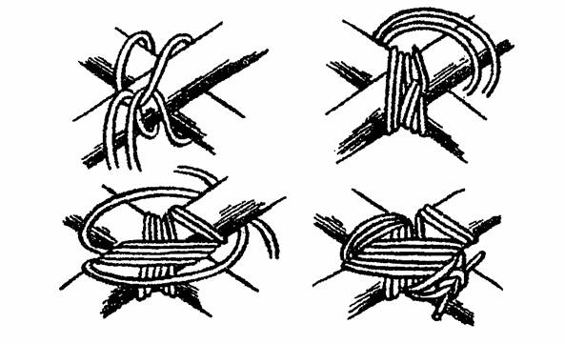

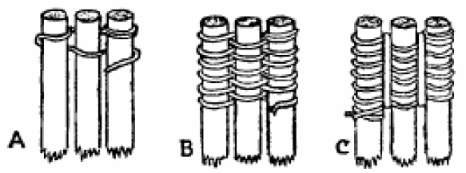

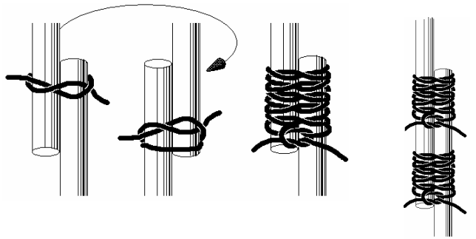

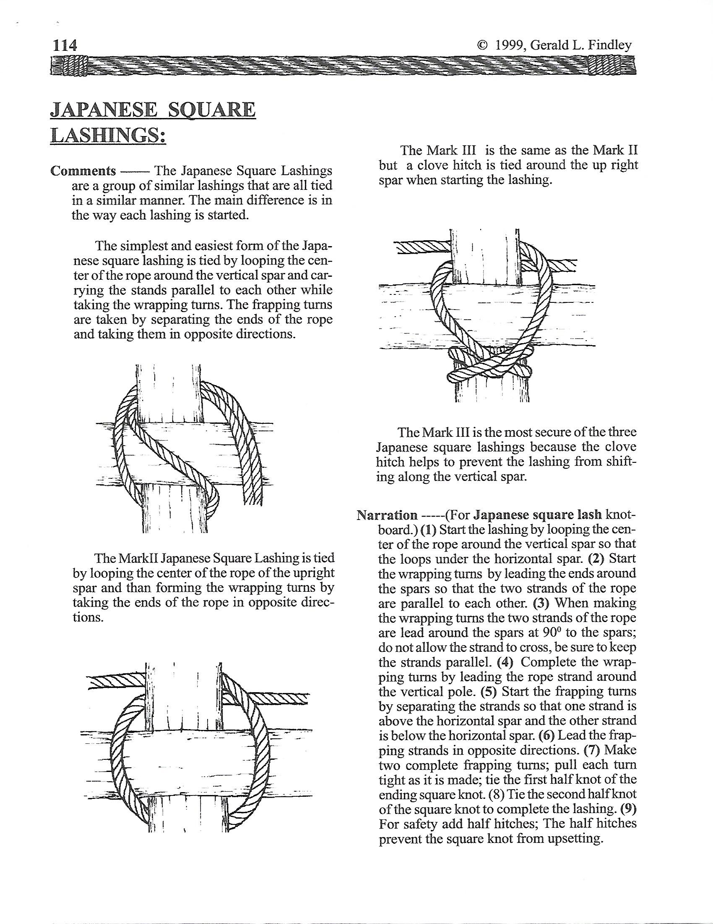
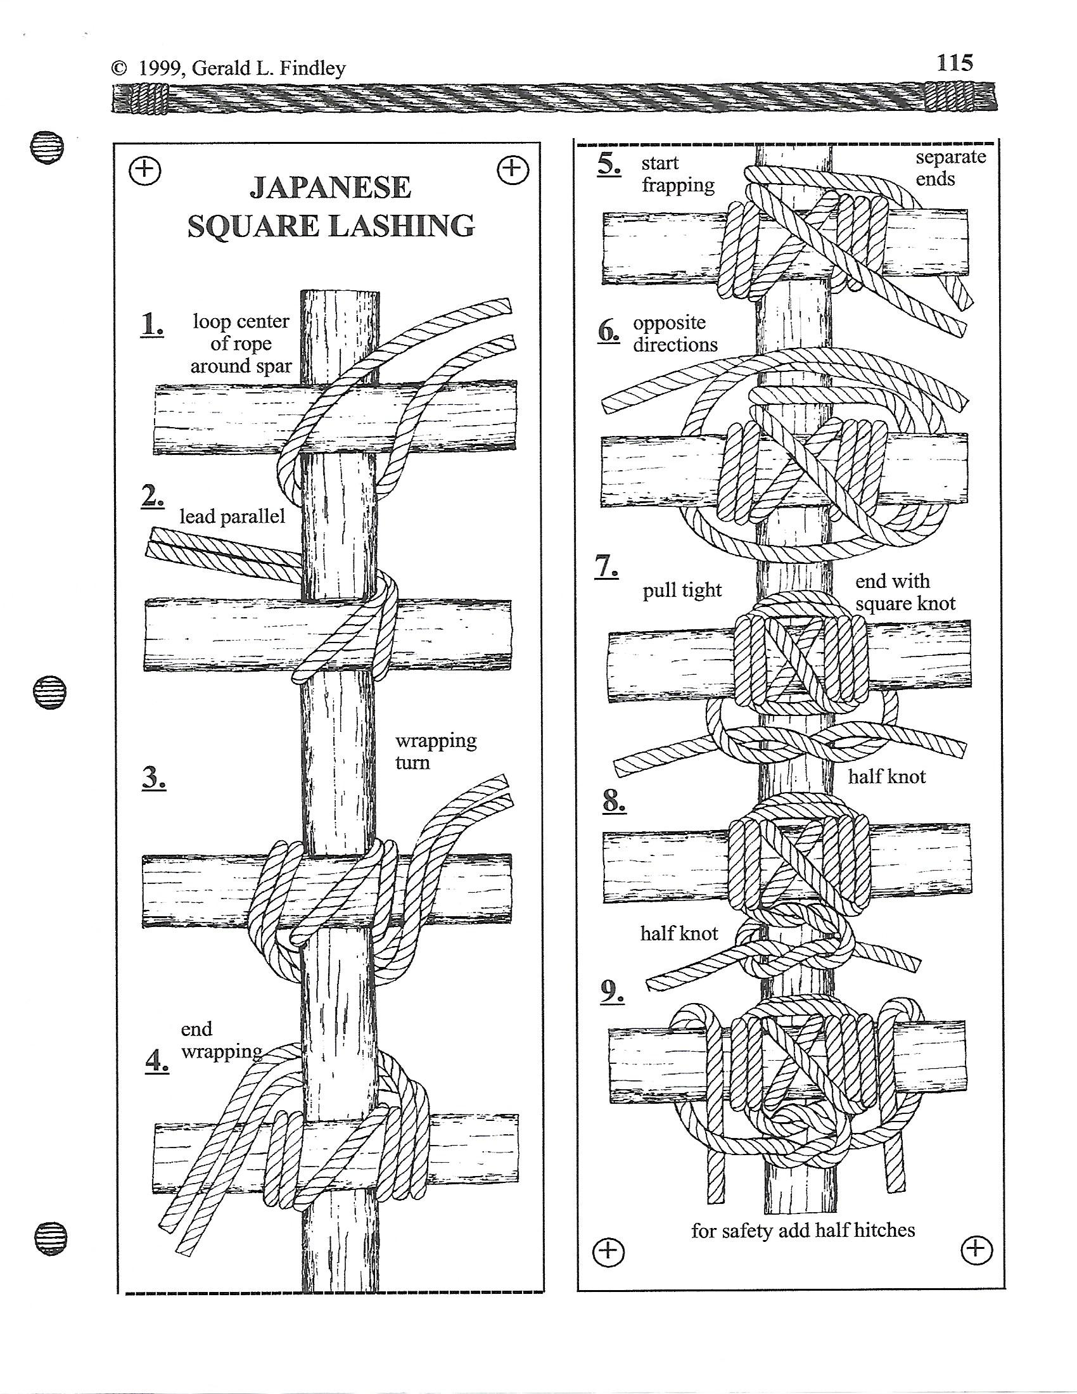
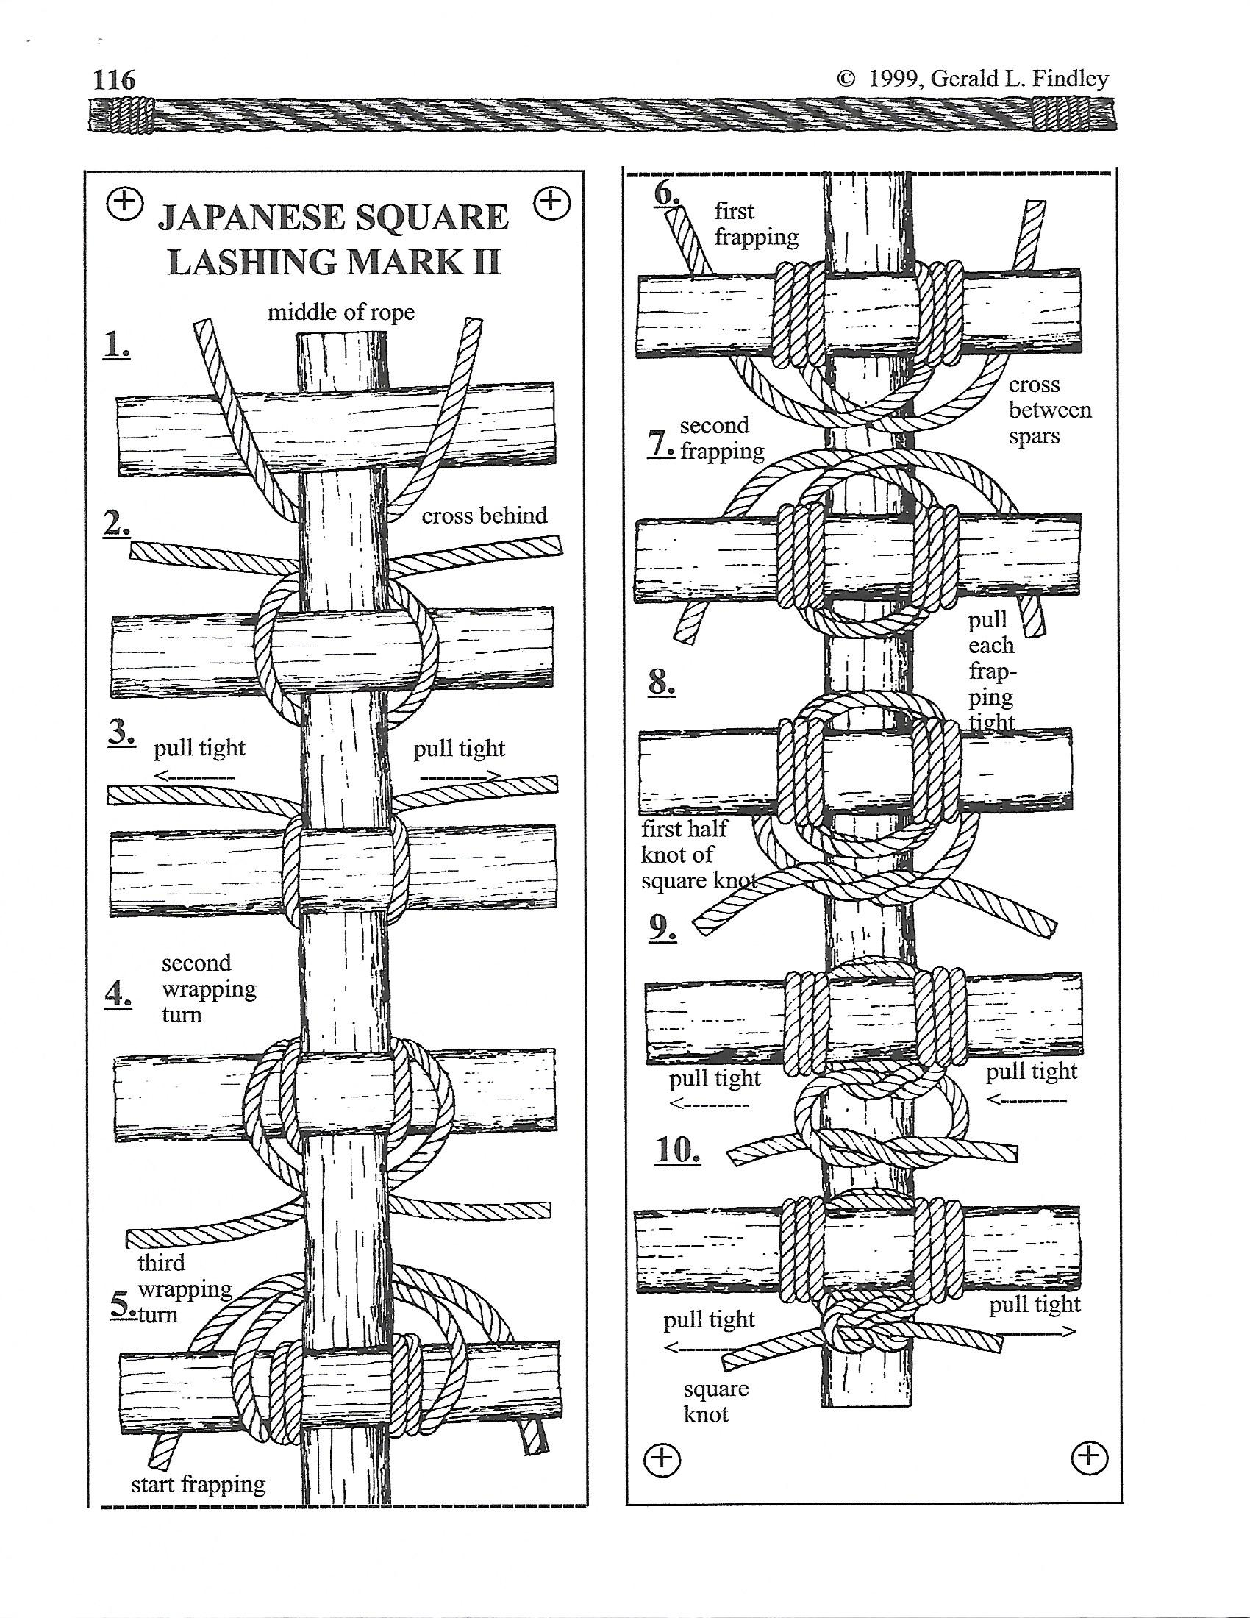
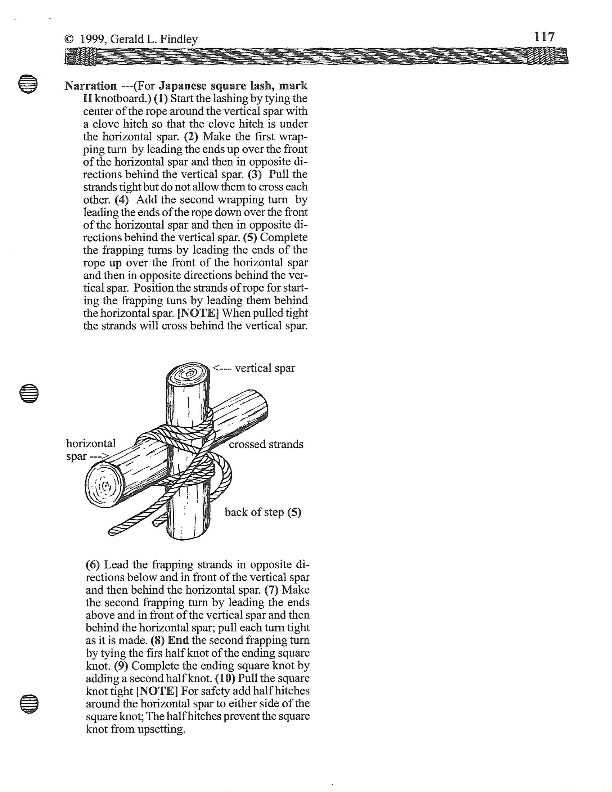
2. Crooked Creek - Milk Crate Stacking
WEBELOS/Scout Division

Location – Nemasket (Site 3)
Task: Try your hand at stacking milk crates, the higher you stack the more gold you get. SCOUTS MAY USE ONLY ONE HAND, NO ROPES WILL BE USED IN STACKING THE CRATES, NO STANDING ON CRATES; ALL SCOUTS MUST HAVE BOTH FEET ON THE GROUND. Scouts may use only one hand and all Scouts may participate. This will be a timed event; you have a total of (5) Five minutes to complete your task. If a stack falls you may try again. Please note that the tallest stack will be the one that is scored and you may stop at any time. All participants must wear a hard hat or bicycle helmet. Ask any questions before starting the event.

18 Crates High | 10 Nuggets
17 Crates High | 9 Nuggets
16 Crates High | 8 Nuggets
15 Crates High | 7 Nuggets
14 Crates high | 6 Nuggets
13 Crates High | 5 Nuggets
12 Crates High | 4 Nuggets
11 Crates High | 3 Nuggets
10 Crates High | 2 Nuggets
1-9 Crates High | 1 Nugget

2a. Rabbit Creek – Hatchet Throwing Competition

**Senior/Venture Division Only**

Location – Shotgun Range - Yukon Territory

Task: Take a chance at a Bulls-Eye. The time has come for competing amongst other teams fighting for Gold Nuggets in this Hatchet Throwing Contest at Rabbit Creek in Yukon Territory.

Prerequisite:

Totin Chip for Senior Division a MUST. No Totin Chip for Ventures

Points Value:
1. | The Bullseye or Black Ring | 8 nuggets
2. | The Red Ring | 4 nuggets
3. | The Blue Ring | 2 nuggets
4. | The Clutch Green Dot | 16 nuggets

Clutch:
  - Players must declare that they are going to throw for Clutch before attempting, also referred to as 'Calling Clutch' or to 'Call Clutch';
  - Players can only throw for Clutch on the 5th and final throw of the round;
  - An accidental clutch is not valid, even on a 5th throw, no call, no points;
  - Once Clutch is called, only that point area is valid and all other point areas are worth zero:
    - Meaning that if a player calls for Clutch but hits a bullseye, they receive no points.
  - A Clutch call can be taken back after it is called but must be announced to their opponent and scorekeeper:
    - If a Clutch call is denounced the target reverts to its original values and the Clutch is worth zero​

Page 1 of 2

2b. Rabbit Creek – Hatchet Throwing Competition

**Senior/Venture Division Only**

Target and Scoring Rings:

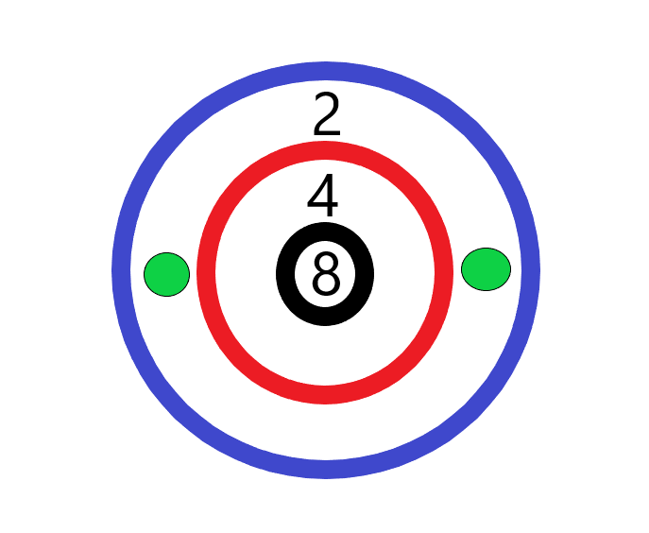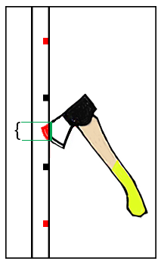

Bonus nuggets:
Additional Nuggets will be awarded for:
1 Naming the parts of the Axe/Hatchet.
2. Safe caring, Handling and storage of the Axe/Hatchet.
3. Displaying Totin Chit.

3. Whitehorse - Travois Building –All Divisions

Location – Mattapoisett (Site 1)
Task: Your patrol leader becomes delirious with fever. You must transport him to the nearest doctor. By using your walking sticks, tarp or blankets and 6 foot lengths of rope from your sledge, you will need to assemble a travois, and transport your patrol leader 50 yards (150 ft.) without dropping him.

**Senior/Venturer** will use Filipino Lashings and Japanese Slashings and will be given the scenario when arrives at station and will need 4 staves (need to carry PL/SPL or President).

Scoring:
1. | Under 4 Minutes | 10 nuggets
2. | 4 Minutes to 4:59 | 9 nuggets
3. | 5 Minutes to 5:59 | 8 nuggets
4. | 6 minutes to 6:59 | 7 nuggets
5. | 7 Minutes to 7:59 | 6 nuggets
6. | 8 Minutes to 8:59 | 5 nuggets
7. | 9 Minutes to 9:59 | 4 nuggets
8. | 10 Minutes to 10:59 | 3 nuggets
9. | 11 Minutes to 11:59 | 2 nuggets
10. | 12 Minutes to 15:00 | 1 nugget

Two bonus nuggets can be had here if you can tell the mayor 2 signs of frostbite.

4. Attu - Snow Shoe Relay – All Divisions
Location - Acooshnet (Site 1E)
Task: Your patrol has found a rare penguin egg worth millions of dollars. On the way back to base camp with the egg, your patrol is caught in a snow slide. Most of the equipment is lost. The snow is waist deep and the only means of transportation is on snow shoes. You have been able to make one long pair of snow shoes from salvaged equipment from your sledge.

When the event is completed, all knots must be untied on each snow shoe. Four Scouts at a time minimum.

**Senior/Venturer** will need all to carry a day-bag (backpack) on their backs such as a school bag with extra clothes in it.

1. | 1 Minute | 10 nuggets
2. | 2 Minutes | 9 nuggets
3. | 3 Minutes | 8 nuggets
4. | 4 Minutes | 7 nuggets
5. | 5 Minutes | 6 nuggets
6. | 6 Minutes | 5 nuggets
7. | 7 Minutes | 4 nuggets
8. | 8 Minutes | 3 nuggets
9. | 9 Minutes | 2 nuggets
10. | 10 Minutes | 1 nuggets

5. Skagway - Wood Splitting

Location – Parade Field (By Dining Hall)

WEBELOS/Scout Division

Prerequisite: Totin’ Chip/Whittling Chip will be required
Task: At this town you will need to cut and split your own wood in preparation for the Kodiak station. You must use a bow saw to cut and a hatchet to properly split the wood provided. You will also need to show and demonstrate the proper use, storage, and sharpening of each tool.

WEBELOS will be required to demonstrate pocket knife safety.

**Senior/Venture Division**

Task: You must use a two man 1800’s style cross-cut saw for 1 complete straight cut, then buck-saw for your 2nd cut, using a splitting mall and hatchet split the wood you cut and your pocket knife to help prep everything you need for your fire.

Objectives to be completed:

1. | Produce Totin Chip/Whittling Chip | 10 nuggets
2. | Knows how to sharpen hatchet | 5 nuggets
3. | Proper use of tool saw/hatchet | 5 nuggets
4. | Clears area before sawing/chopping | 5 nuggets
5. | Identifies parts of hatchet | 1 nugget/part

6a. Kodiak - Fire Dousing

**WEBELOS/Scout Division Only**
Location – Cadre (Behind Handicraft)
Prerequisites: Firem’n Chit/Outdoorsman Badge & complete wood splitting at Skagway.

Task: At this town you will build a fire lay no higher than 12 inches. Light the fire without the use of matches. Burn through the upper mark, 24 inches, and melt bag, releasing water to extinguish the fire.

Flint and Steel only will be allowed. You will be timed from the first attempt to light the fire until the release of the water. You must tell the judge when you are ready to start; the judge will inform you when you may start. After starting the fire you may not add fuel. You will be allowed to fan and /or shield your fire from the wind. Lint will be provided by the Mayor. Once the fire is lit for 2 minutes then the string will be strung and the timing of the event will begin.

WEBELOS will be allowed to supply their own kindling and tinder for this event. Bare clean wood only!

Scoring: Scout Webelos Division
 | Fire is lit and burning for 2 minutes (or if nest is lit) | 5 nuggets
 | Burn String in 7-10 minutes | +1 nuggets
 | Burn String in 6-6:59 minutes | +2 nuggets
 | Burn String in 5-5:59 minutes | +3 nuggets
 | Burn String in 4-4:59 minutes | +4 nuggets
 | Burn String in 3-3:59 minutes | +5 nuggets
 | Burn String in 2-2:59 minutes | +6 nuggets
 | Burn String in 1-1:59 minutes | +7 nuggets
 | Burn String in 39-59 seconds | +8 nuggets
 | Burn String in 19-58 seconds | +9 nuggets
 | Burn String in 0-18 minutes | +10 nuggets

Scoring: One nugget will be awarded to each team member showing their firem’n to the Mayor upon entry to the town with asking. It will not be the responsibility of the mayor to ask for a firem’n chit from any team member not involved directly in the lighting of the fire.

6b. Kodiak - Fire Dousing

**Senior/Venture Division Only**
Location – Cadre (Behind Handicraft)
Prerequisites: Firem’n Chit/Outdoorsman Badge & complete wood splitting at Skagway. Firem’n Chit not required for Venturers.

Task: At this town you will build a fire lay no higher than 12 inches. Light the fire without the use of matches. Burn through the upper mark, 24 inches, and melt bag, releasing water to extinguish the fire.

Bow and String Fire Drill. You will be timed from the first attempt to light the fire until the release of the water. You must tell the judge when you are ready to start. Using bow and string fire drill starting kits will be at station if you don’t have your own. The nest material needed for your spark will be given to you by the mayor to make your nest. In this station, you can add your tinder as needed to build the flame in the first 2 minutes after adding nest. The fire must stay lit for 2 minutes minimum ...you must use fire gloves to pick up the lit nest.

Scoring: If you light the nest you get 5 nuggets
1. | 1-6 minutes | 10 nuggets
2. | 6-8 minutes | 9 nuggets
3. | 8-10 minutes | 8 nuggets
4. | 10-12 minutes | 7 nuggets
5. | 12-14 minutes | 6 nuggets
6 | 14-16 minutes | 5 nuggets
7. | 16-18 minutes | 4 nuggets
8. | 18-20 minutes | 3 nuggets
9. | 20-22 minutes | 2 nuggets
10. | 22-30 minutes | 1 nuggets

One nugget will be awarded for each team member who shows the Mayor their firem’n chit. It will not be the responsibility of the mayor to ask for a firem’n chit from any team member not involved directly in the lighting of the fire. There is no such thing as a Venture’s firem’n chit so to make it fair, they will be given 1 nugget per participant.

7. Satan’s Landing - Chasm Crossing – All Divisions

Location - Scoutcraft
Task: Your patrol is proceeding down a trail in search of gold. You come across a bridge that has been washed out by a storm. The only things spanning the 100ft Chasm are 2 railroad planks laying side by side and 6 poles to use as rollers. Your problem is to get the entire patrol, along with your sledge and equipment, across safely without falling into the chasm. If a Scout falls or steps off the planks and his feet touch the ground, he is considered dead and cannot continue to help. If your sledge falls off, you must start again.

1. | Less than 1 Minute | 10 nuggets
2. | 1 Minute to 1:59 | 9 nuggets
3. | 2 Minutes to 2:59 | 8 nuggets
4. | 3 Minutes to 3:59 | 7 nuggets
5. | 4 Minutes to 4:59 | 6 nuggets
6. | 5 Minutes to 5:59 | 5 nuggets
7. | 6 Minutes to 6:59 | 4 nuggets
8. | 7 Minutes to 7:59 | 3 nuggets
9. | 8 Minutes to 8:59 | 2 nuggets

8. Dead Horse - First Aid –All Divisions

Location – Health Lodge
Task: In this town you will be given scenarios at check-in. When you check in with the mayor a scenario will be selected at random and your team will be required to demonstrate treating a person with an injury.

**Webelos/Scout Division**
Task: The questions & demonstration will come from the Webelos and Boy Scout handbook and the Boy Scout field book.

**Senior/Venture Division**
Task: For your Task at this station you will need to know 1 handed bowline, splint and bandages, you will be given your scenario when you arrive at this station. Splints and rags will be provided for your use.

All: Think about what steps you should take, and also what sequence you should correctly follow.

You will be given 2 gold nuggets for each correct answer.
You will be given up to 12 gold nuggets if the sequences are correct.
Be ready for bonus questions!
All these emergencies and first aid scenarios are written to make you think about treating various types of situations and injuries. At the same time not making things worse for the injured or for the Webelos Den/Boy Scout Troop/Venture Crew itself.
The plan is to treat the injuries and get the injured person the correct and best help as quickly as you can, or to avoid these types of problems in the future. The scenarios will be provided to the patrol leader at registration.

Total _______________ for correct answers

Total _______________ for correct sequence
Total _______________ points for first aid.
9. Fort Yukon – Rifle Competition—All Divisions

Location – Rifle Range
Task: Your patrol has just entered a rifle competition for bragging rights in the Yukon Territory (Tom Cullen Field). Using a 22 caliber for Scout Division and black powder for **Senior/Venture Division** (BB guns for WEBELOS) each Scout will be given 5 shots at targets. Each target score will be added together and then divided by the number of shooters to arrive at an average score. WEBELOS will use BB Guns. Your sledge will have a total of 2 ½ minutes to make all 5 shots.

THERE IS A ZERO TOLERANCE POLICY FOR HORSEPLAY OF ANY KIND ON THE RANGE. ANYONE CAUGHT WILL BE ASKED TO LEAVE THE RANGE.

If a person is asked to leave, his score will not count, and the total number of shooters will not change.

1. | Score 1 - 10 | 1 nugget
2. | Score 11 - 20 | 2 nuggets
3. | Score 21 - 30 | 3 nuggets
4. | Score 31 - 40 | 4 nuggets
5. | Score 41 - 50 | 5 nuggets

10. Sourdough - Knot Knowledge—All Divisions

Location - Yukon Territory (Tom Cullen Field) near entrance to Archery)
WEBELOS/Scout Division
Task: Using the ropes available on your sledge, each team member must demonstrate your knowledge of knots from handbook, each knot identified, told what it is used for and tied correctly for a maximum of 3 nuggets per knot.

**Senior/Venture Division**
All of these knots may be found on these internet sites…realknots.com and animatedknots.com--These sites will teach you how to tie the knots:
    - Figure eight knot
    - Double eight knot
    - Alpine butterfly knot
    - Zeppelin knot
    - The Carrick Bend / The Josephine Knot
    - True lovers knot / Fisherman’s knot
    - Timber hitch
    - Blood knot

Knot | Use | Tied Correctly | Total Points
 |  | Total

11. Valley Forge – Lunch—All Divisions

Location – Pine Grove

Prerequisite; Firem’n Chit/Outdoorsman Badge
Task: You have been on the trail all morning, your team is starting to get tired & worn down from the hilly terrain and tough walking. You decide to break for lunch, park your sledge in Yukon Territory (Tom Cullen Field). Your patrol leader checks in with the Mayor and you will be assigned an area for the team to cook in. Oven mitts or other heat/flame resistant gloves are required for this even. Using your clean (no used paint cans) #10 can with handle & oven mitts (no nylon gloves, jackets or pants shall be worn to retrieve charcoal) you obtain some lit charcoal & place it in the garbage can cover to cook with. Your team, without the help of adults; makes lunch over the charcoals using your written menu & duty roster.
ALL members of the patrol must eat a cooked meal. More nuggets are given for originality of the meal prepared. You will be judged on teamwork during preparation, clean-up, organization and cooking skills. The judges could be sampling your meals! Don’t forget your drinks and desserts.
The frost free water spigot is “Off Limits” to all Scouts. Washing and rinsing of dishes/pans should be done in wash buckets. Heated wash water will be provided for clean-up. Don’t forget to check in/out with the mayor to get credit for this town. NO EXCEPTIONS!
Scoring:
Preparation | 1-15 nuggets
Organization | 1-15 nuggets | - 10 nuggets for no gloves
Cooking Skills | 1-15 nuggets
Clean-Up | 1-25 nuggets
Each firem’n chit/  Outdoorsman Badge | 1 nugget for each chit/badge | Maximum 4 points based on sliding scale

WEBELOS:
WEBELOS Leaders and Den Chiefs will be allowed to assist WEBELOS Scouts at this station. Boy Scouts\Den Chiefs must have firem’n chit.

12. ChilKoot Pass – Compass Course
Location – Staff Site -- Waterfront
Task: The compass course for both Boy Scouts and WEBELOS Scouts will be passed out at Registration. Boy Scout Webelos Den/Boy Scout Troop/Venture Crews can earn (5) extra nuggets if they complete the WEBELOS compass course correctly.

WEBELOS:
This town will test the team’s ability to locate the main trail that they were following. They were forced to leave the trail to escape the grizzly bear that was looking for a midwinter snack.

WEBELOS/Scout teams can earn (5) extra nuggets if they complete the Boy Scout Compass Course.

Preparation requirements are;
- Know your compass and how to find directions.
- Know how to take accurate bearing readings using your compass
- Have the ability to box up to 32 points on a compass rose
- Know the difference between Azimuth and Direction

A chart will be provided the day of the Klondike to assist you in labeling the direction.

Score Sheet and Gold Nuggets to Follow…

Distance Counter

Below is a drawing of a distance counter. Use this to count off your paces for the compass course/pace counter event. Directions on how to use the pace counter can be found at http://usScouts.org/Scoutcraft/dc/makedc.html.

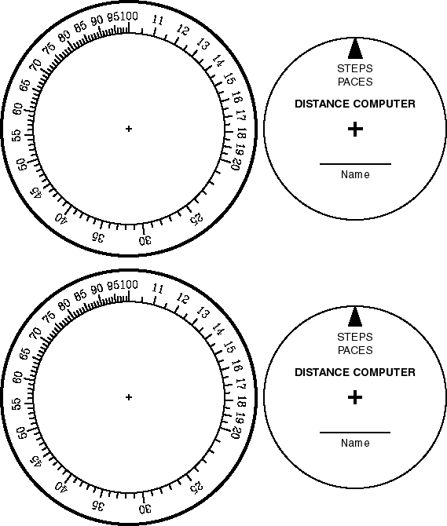

Compass Rose

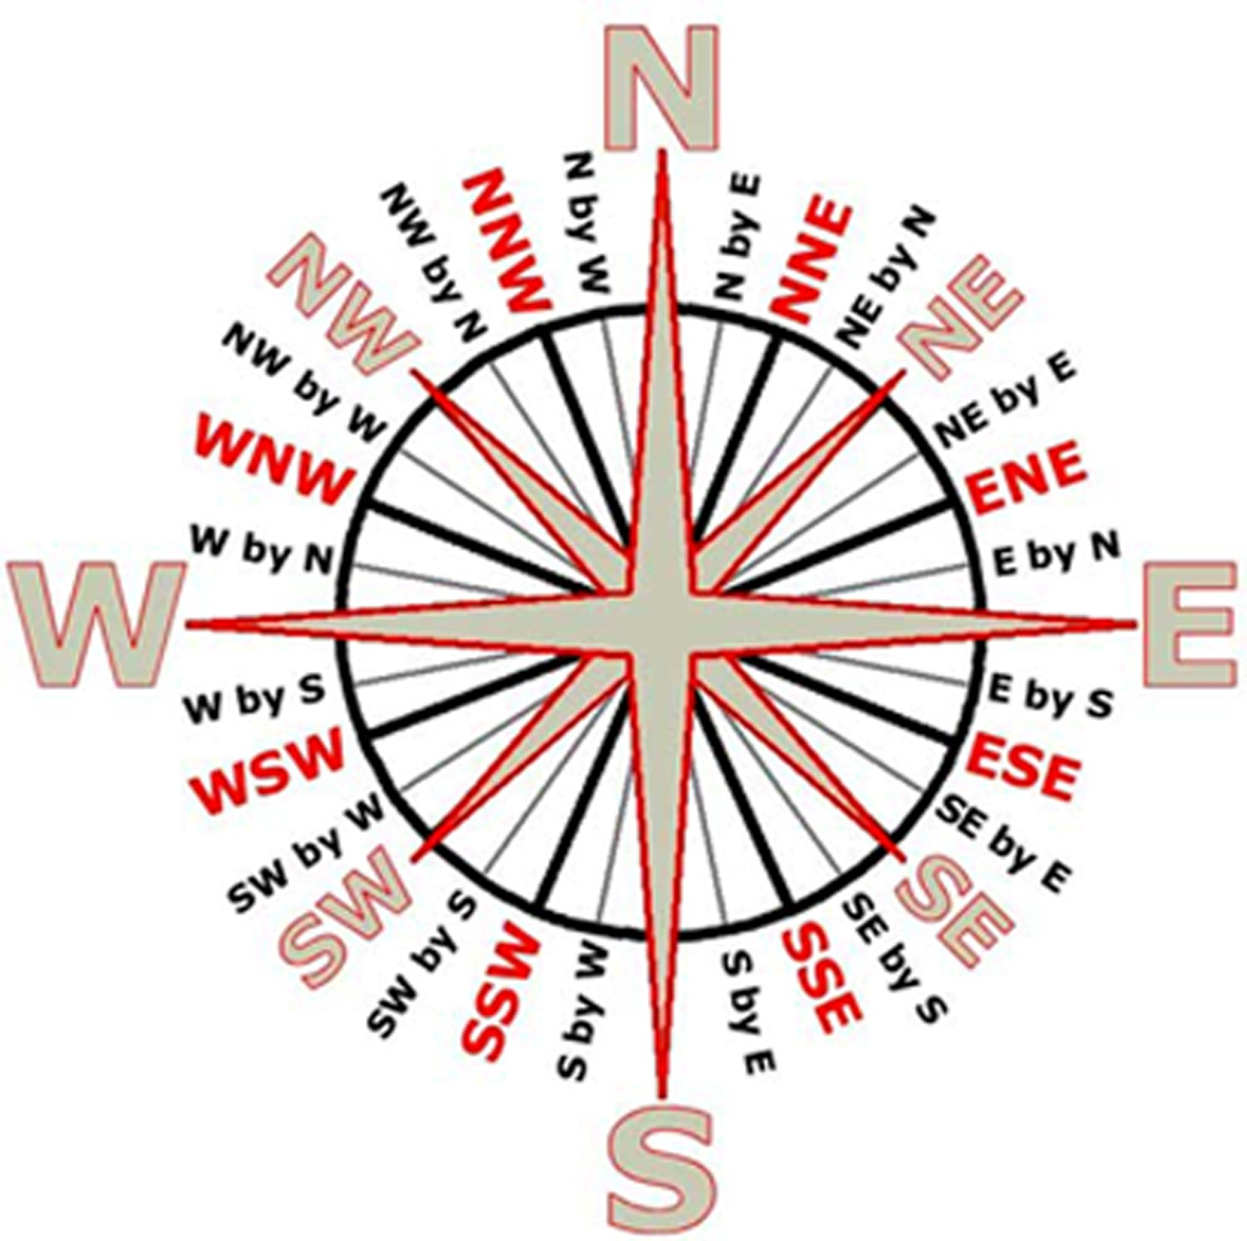

13. Call of the Wild – Nature Scavenger Hunt—All Divisions
Task: Your patrol leader will be given a list of fifteen items. These items will be nature related and readily available throughout the day. You should not need to extra time during the day to find these items. They will all be easily found either between towns or nearby while you are waiting to participate in a town. A maximum of 20 gold nuggets can be earned for this activity.
A Nature Scavenger Hunt list will be provided the day of the Klondike Derby at registration.

14. The Great Sledge Race—All Divisions

Location: Yukon Territory (Tom Cullen Field)
Starting at 4:00PM at Yukon Territory (Tom Cullen Field) is the last push of the day. No nuggets will be given for this race. The race will consist of six to eight sledges from each division, racing from one of the field to the other end and then back. If needed, several heats from each division will be held to narrow the field. The one race will be held to determine the winner of each division. The Senior division will race first, followed by the Scouts and then the WEBELOS.

THIS PAGE INTENTIONALLY LEFT BLANK

2018 Klondike Derby
Weigh – In Check List
Please give this form to the weigh –in station mayor

Webelos Den/Boy Scout Troop/Venture Crew #_________ Patrol Leader_____________________________________

Total # Boys on Sledge_________ Patrol Name__________________________

# | Item |  | X
1. | Patrol Leader arm band (must have “PL” on it)
2. | Notebook or clipboard and method to keep score sheet dry
3. | Rain Gear for each member of team (Must be jacket or Poncho)
4. | (1) Pace counter for each team member
5. | (1) Hot cup for each Scout
6. | A complete change of clothes for each Scout
7. | (2) packaged hand warmers per Scout
8. | Patrol Flag
9. | (1) Boy Scout /WEBELOS Scout handbook per sledge
10. | First Aid Kit (from Boy Scout Handbook for Webelos Den/Boy Scout Troop/Venture Crew/patrol (**See below)
11. | (2) Compasses per sledge
12. | (1) Roll of toilet paper
13. | Trash Bag (for rubbish)
14. | (1 Pair) Cooking gloves or oven mitts
 | Nuggets scored: (Max. 14) (Subtract 1 nugget for every item missing, **Subtract 10 nuggets each for first aid kit)
Sledge Weight | LBS | Nuggets scored (max 14) (Subtract 1 for every 5lbs. under 50lbs. total weight

THIS PAGE INTENTIONALLY LEFT BLANK
Klondike Derby Sledge Registration

Please have this form ready for registration at Dawson City (The 21 Club) the day of the event.

Service Area_____ Webelos Den/Boy Scout Troop/Venture Crew/Pack/Crew_______ Adults ________ Adults as Staff _______

Total Paid Adults____________ Total Paid Scouts_________ Total Patches__________

#1 Patrol Name_______________________ #2 Patrol Name _____________________

Scout Name | Age | Scout Name | Age
Average Age |  | Average Age

Division: Scout Senior/ Venture WEBELOS Division: Scout Senior/ Venture WEBELOS

#3 Patrol Name_______________________ #4 Patrol Name _____________________

Scout Name | Age | Scout Name | Age
Average Age |  | Average Age

Division: Scout Senior Venture WEBELOS Division: Scout Senior Venture WEBELOS

Divisions: WEBELOS 10-11 years of age
Scout 11-17 years of age (Average Patrol Age 13.9 or Less)
Senior 11-17 years of age (Average Patrol Age 14.0 or Greater)

Venturer 14-21 years of age (Boys and Girls)

THIS PAGE INTENTIONALLY LEFT BLANK
Score Sheet

Circle Division: SCOUT SENIOR VENTURE WEBELOS

Patrol Name: | Webelos Den/Boy Scout Troop/Venture Crew:
# of Scouts: | Town:
Start Line Time: | All Stations Complete: Y N
Start Time: | End Time:

Start at X after Weigh-in | Station | Event | Time In | Time Out | Nuggets Scored
Shotgun Range | 2B* | Rabbit Creek -- (Hatchet Throwing)
Boat House | The Outfitters (Boat House) Field | Weigh-in
Sconticut | 1 | Cheechaku (shelter setup)
Nemasket | 2A | Crooked Creek (milk crate stacking)
Mattapoisett | 3 | White Horse (travois building)
Acooshnet | 4 | Attu (snowshoe relay)
Parade Field | 5 | Skagway (wood splitting)
Cadre | 6 | Kodiak (fire dousing)
Scoutcraft | 7 | Satan’s Landing (chasm crossing)
Yukon Territory (Tom Cullen Field) (S) | 8 | Dead Horse (first aid)
Rifle Range | 9 | Fort Yukon (rifle)
Yukon Territory (Tom Cullen Field) (N) | 10 | Sourghdough (knots)
Pine Grove | 11 | Valley Forge (cooking)
Chil Koot Pass  Staff Site—Waterfront | 12 | WEBELOS Compass Rose
“ | “ | WEBELOS Direction Finding
“ | “ | Boy Scout Compass Course and Compass Rose
 | 13 | Call of the Wild
 |  | Scavenger Hunt
 |  |  | TOTAL SCORE
- Station Layout Map Provided.
- All patrols must start at first assigned station.
- All stations must be done in assigned order.
- Scavenger Hunt and Compass Course may be handed in at 21 Club anytime after lunch.
- Scavenger hunt starts after weigh-in
- Sledges leaving Sourgdough will go to Cheechaku
- Lunch will start at 12:00 Noon

THIS PAGE INTENTIONALLY LEFT BLANK

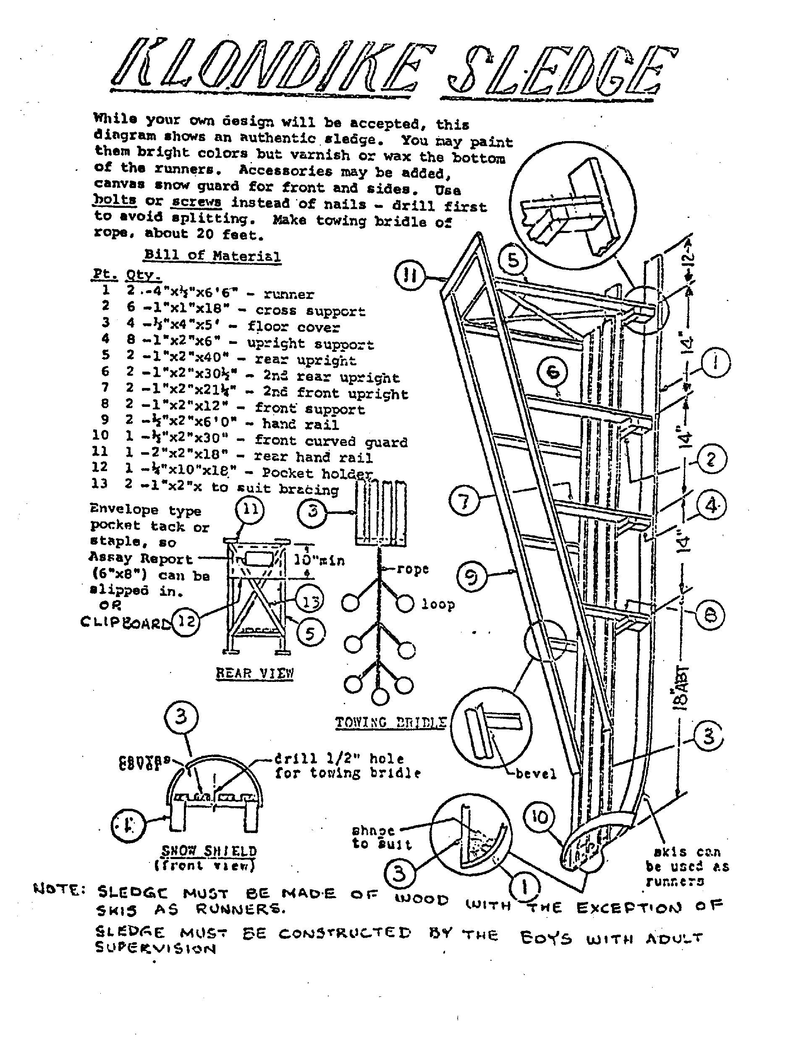
Length = not less than 6 feet Width = not less than 18 inches
Height = not less than 3 feet Weight = not less than 50 lbs.

Check in: at The Outfitters (Boat House) Field

Registration: at Dawson City (The 21 Club) – only PL allowed in.

1. Cheechaku – Shelter set-up Sconticut (Site 3N)
2. Crooked Creek – Milk Crate Stacking Nemasket (Site 3E)
3. Whitehorse – Travois Building Mattapoisett (Site 1W)
4. Attu – Snowshoe Relay Acooshnet (Site 1E)
5. Skagway – Wood splitting Parade Field (by Dining Hall)
6. Kodiak – Fire Dousing Cadre (behind Handicraft)
7. Satan’s Landing – Chasm Crossing Scoutcraft
8. Dead Horse - First Aid Yukon Territory
(Tom Cullen Field)
near entrance to Scoutcraft

9. Fort Yukon – Rifle Shooting Range
10. Sourdough – Knot Knowledge Tom Cullen Field near
entrance to Archery

11. Valley Forge – Lunch Pine Grove
12. Compass Course Crooked Creek
(Milk Crate Stacking)

13. Call of the Wild – Nature Scavenger Hunt Throughout Camp
14. The Great Race Yukon Territory
(Tom Cullen Field)

First Aid and Emergency Scenarios
All these emergency and first aid scenarios are written to make you think about treating various types of situations and injuries. At the same time not making things worse for the injured or for the Webelos Den/Boy Scout Troop/Venture Crew itself. The plan is to treat the injuries and get the injured person the correct and best help as quickly as you can, or to avoid these types of problems in the future.

SCENARIO 1
While out on a backpacking hike the Webelos Den/Boy Scout Troop/Venture Crew comes around a corner of an area of the trail with a steep 40 foot cliff on one side of the trail and an equally steep 20 foot drop on the other side of the trail. Lying in the middle of the trail is an unconscious person with an obvious broken leg. He has a hard hat on his head and is wearing equipment appropriate for rock climbing, and you can see there are ropes still attached to the cliff face. There is also a large heavily bleeding cut on his arm, and a bruise on his forehead.
TASK - List the steps you would take to help secure this person and get medical help without jeopardizing further injury.

SCENARIO 2
While out on a backpacking hike the Webelos Den/Boy Scout Troop/Venture Crew comes around a corner of an area of the trail with a steep slopping hill on one side of the trail and a thickly forested area on the other side of the trail. Lying in the middle of the trail is a conscious but confused male person with an obvious broken leg. He has a large back pack lying on the ground beside him. He is wearing clothing appropriate for a hike into the woods, and is carrying equipment appropriate for a long self-sustained stay in the woods. There is a large heavily bleeding cut on his arm, but no apparent other injuries.
TASK - Please list the steps would you take to help secure this person and get medical help.

SCENARIO 3
While being driven by adult leaders to a site a good distance from home, a Webelos Den/Boy Scout Troop/Venture Crew comes upon a multi-vehicle car accident on a road that is not heavily traveled. There are a fairly large number of people injured, but none appear serious and everyone is conscious and able to speak, and tell you what hurts. There is the smell of gasoline in the air, but there is no fire. The cars are heavily damaged.
TASK - What steps would you as a Webelos Den/Boy Scout Troop/Venture Crew take to assist the people involved in the accident without endangering them or the members of your Webelos Den/Boy Scout Troop/Venture Crew?
SCENARIO 4
Your Webelos Den/Boy Scout Troop/Venture Crew is out on what was planned as a long summer hike with daypacks and minimal equipment in the mountains. You all have water and trail food, and some articles of clothing in your packs. In the beginning the day was 80 degree temperatures and sunny, but the weather begins to change from warm sunny skies to foggy and cooler temperatures down into the 50’s. After a while one Scout begins to say he is getting cold. Shortly after that he begins to shiver and complain more about his legs hurting. Everyone is getting damp from walking through the fog, which is now getting very thick and visibility is rapidly diminishing.
TASK - What is happening and what steps should you do to help the Scout and the rest of your Webelos Den/Boy Scout Troop/Venture Crew to get through this?
SCENARIO 5
While out in the woods camping, your Webelos Den/Boy Scout Troop/Venture Crew is taking a day hike along a trail at a pretty quick pace. Yet you need to stop to catch your breath and to take a drink of water from your bottle. It only takes a couple minutes, but when you begin to hike again, you come up to a fork in the trail with three different trails you could take. Your Webelos Den/Boy Scout Troop/Venture Crew is out of sight, and you cannot hear their voices. So you take the trail that appears the heaviest traveled. You pick up your walking pace, but despite your best efforts you can’t catch up to your Webelos Den/Boy Scout Troop/Venture Crew. You’re not sure you actually took the right trail, and suddenly you’re not sure what to do next. You have next to nothing with you on the hike, only your water bottle, and a small almost empty daypack.
TASK - What should you have done to not allow this to happen? What equipment should you have brought with you just for emergency moments like this?
What steps do you take to help yourself?

Camp Cachalot

39th Annual Klondike Derby

Scouts can design the patch for next year’s Klondike
Send all logo designs to Paul Dupont
pduponttroop24@comcast.net

Camp Cachalot
January, 2019

