Explanation Sheet for Wagons
Chuckwagon 2019 ~ “Mythical Creatures”

Our main objective is to HAVE FUN!

In the morning, report to the Wagon Inspection station (after registering) and have 1 adult remain with the wagon until you are inspected. After inspection, you will be awarded a special item to show, if asked, throughout the day. Wagon inspection is MANDATORY!

Each wagon has a wagon number. Wagon numbers will be: 101-120, 201-220, 301-320, 401-420 and 501-520. Your number will be given to you at the Nicholson Administration Building when you come in to register your wagon. The rank of the wagon is determined by the rank of the oldest Cub.

Beads are given out at each station for each paid member of a wagon. You can get Den Doodles (Leather disc that the beads and plastic lacing/gimp tie onto) at the Lighthouse craft area. Putting the Doodle together is a good way to pass the time while waiting in line at a station.

All adults should be helping station leaders. We are all volunteers and we work best as a team! Please pay attention to the set schedule. The schedule puts wagons at specific areas to ensure that everyone gets to go to every station. Please stay in your designated area to be fair to other wagons. If you arrive at another area early, you are taking someone else’s turn. This is not allowed.

Keeping the station open after the set close time is not allowed. Please respect what the station Leader says. All stations will close at 3pm. That is the only way we can start awards at 3:30 and be over near 4pm.

We will have 1 large Archery station and 2 BB stations. You will be given a set time, when you register, for what time and which range you will go to. If you miss your time, you may not get a second chance. The ranges will have a master copy of the times for the wagons. (More than 8 Scouts on a wagon will interfere with shooting sports.)

Everyone, even station Leaders, deserve a break. Please understand if you need to wait while the station Leader steps away for a few minutes. Offer to help, if possible.

Special awards will be given out to any wagon that should be recognized. If you have something that is noteworthy about a wagon, in a good way of course, please let a station Leader know so they can turn it into the Nicholson Camping Center by 1pm. You may stop at the Nicholson Center yourself, to recognize a wagon.

Please do not leave the Saturday Show until you are dismissed. People leaving after their awards are finished are disruptive and disrespectful to the other Scouts.

For First Aid assistance, come to the Nicholson Center. Please drink plenty of water. Bottles may be refilled at any of the theme areas. The bathroom tap water is safe to drink (I’ve been drinking it for years and I’m still here).
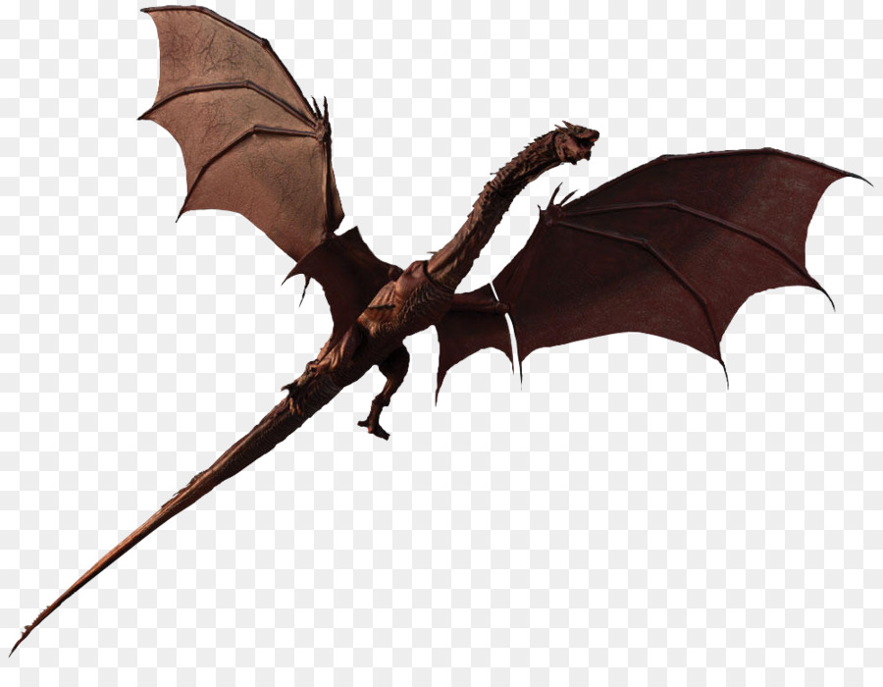
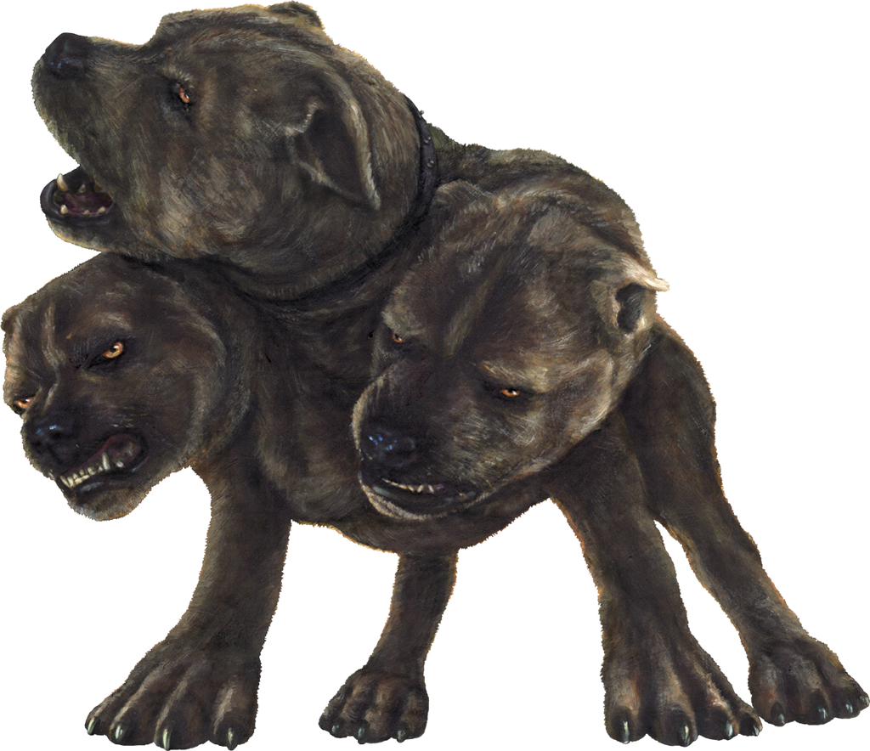
Everyone should have a trash bag on their wagon. There is NO excuse for littering. Please Leave No Trace!
HAVE FUN!
Flo Stevens
401-692-6716 ~ newtfla@gmail.com

