Chuckwagon
At Cub World
Saturday, May 18, 2019
From 7:00 a.m - 4:00 p.m.
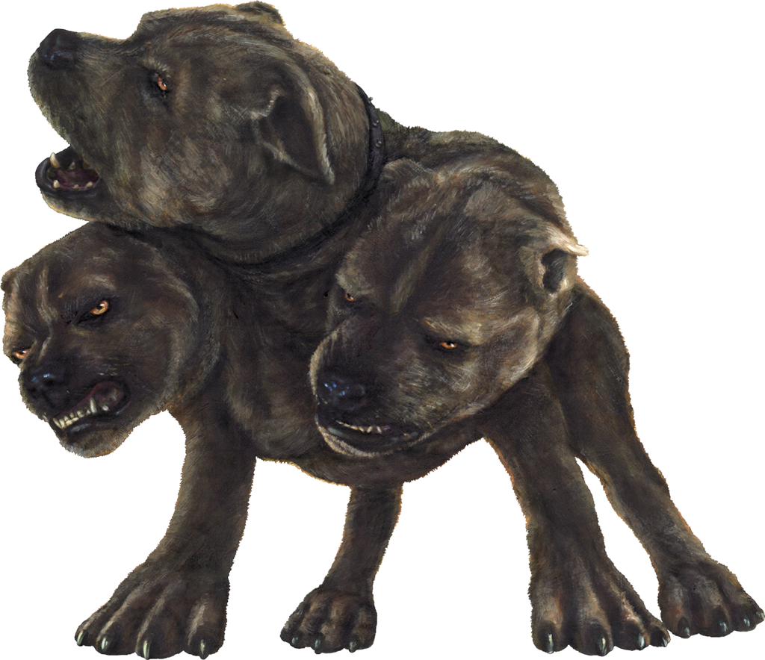
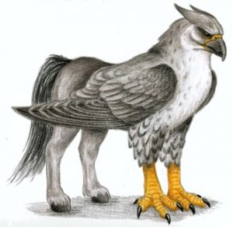
Cub Scouts compete for ribbons at stations that test traditional Cub Scout skills as well as stations that are just for fun. Each Cub Scout Den will load all of their gear on a wagon and travel from station to station. Two adults per wagon is suggested. Cost will be $30 per parent/Cub Scout team or $15.00 per person. Parking is LIMITED, please carpool. You must preregister by Friday, May 10th in order to guarantee your Scout receiving a gift bag and there being enough patches. These will be handed out at the registration window.

This year’s theme is: “Mythical Creatures”

Remember to bring your Den Chiefs. They may stay with your wagon or help at a station!
All Cub Scout Packs are invited to join us at Cub World. It is REQUIRED that a registering Pack helps to run a station. There will be a Station Leader’s meeting at the Amica Building Roundtable, Wednesday, April 10, 2019.

Webelos,
please join us after the Chuckwagon for a Webelos Overnighter to have fun and work on the Webelos Required Adventure “Duty to God” and the Elective Adventure “Adventures in Science”.
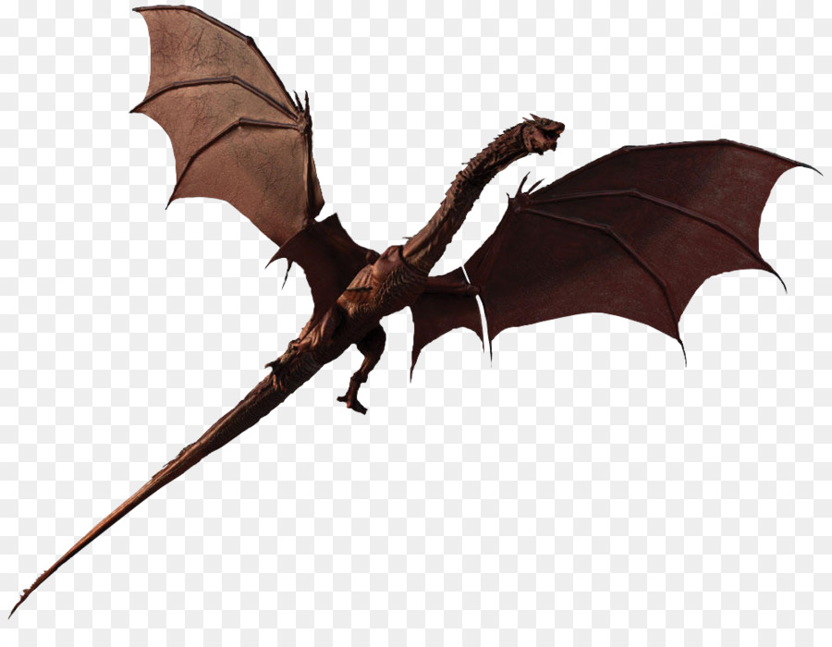
Cost will be $30.00 per Cub Scout and $30.00 per Adult Leader or $60 per parent/Scout team (Chuckwagon fee is included). Parent/adult is required.

The Theme is: “Mythical Creatures”

For more information or if you’re interested in running a station, contact Flo Stevens at Home: 401-568-0395 Cell: 401-692-6716 ~ newtfla@gmail.com

