WEBELOS
OVERNIGHTER
Saturday, May 5 -6, 2018
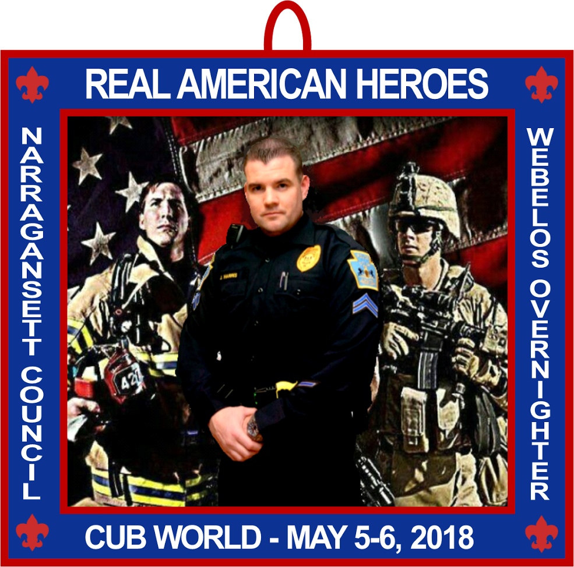
This will immediately follow the Chuckwagon, beginning at 4pm. Earn the Webelos Required Adventures “Duty to God and You” and “First Responders”

“Ground Zero”

All WEBELOS Welcome!

Cost will be $50.00 for the Parent and Scout Team.
(This includes the $20 Team fee for the Chuckwagon)
Additional Webelos $25 (including the $10 Individual fee)

Join us at Cub World for an evening of food, fun, adventure,
campfire and many Webelos centered activities!
For Dinner wear a First Responder Outfit or your Class A Uniform.
Bring your tent!

Think of a song or skit for the campfire!
Refer to the “Items Needed” sheet for a packing list.
Please register early. There are a limited number of spaces.

Contacts: Flo Stevens: 401-568-0395 ~ Cell: 401-692-6716 ~ newtfla@gmail.com
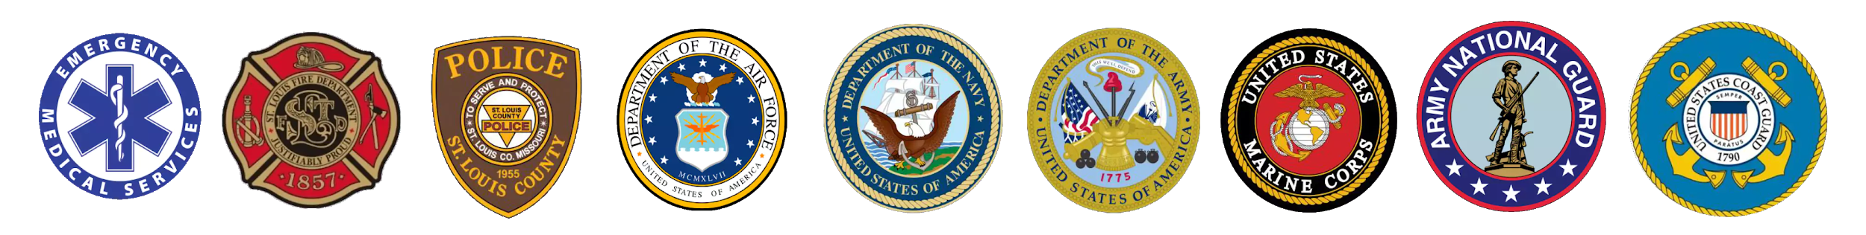
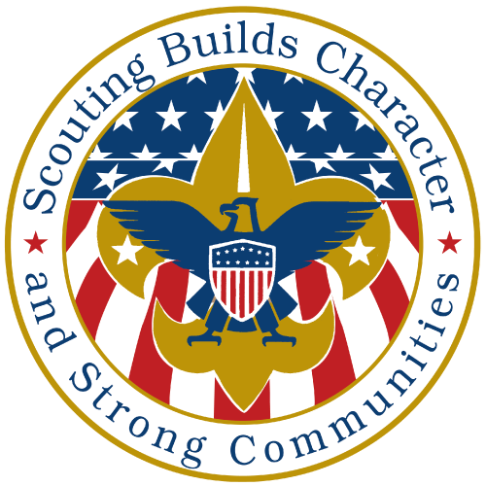
Patty and Martin Gomm: 401-222-0920 ~ pgomm@courts.ri.gov

