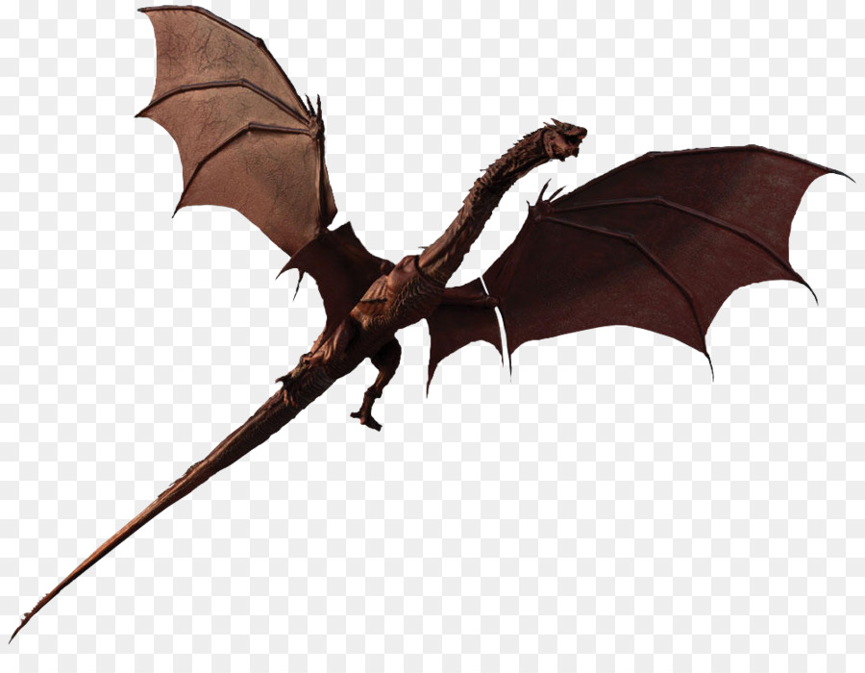
2019 Chuckwagon
“Mythical Creatures”
Helpful Hints for Packs

Parking is LIMITED; please CARPOOL if possible. The later you arrive, the further away you will need to park.
NO Pets are allowed at Cub World.

Check-in is from 7:00 – 8:00 am -- please be on time! To reduce the check in line, we will open registration on Friday evening. (Please contact us for times.)
FIRST – Send an adult to the check-in window. Here you will be assigned a wagon number and issued the Scout gift bags, one for each paid Scout. The patches will be given separately for each paid Scout and adult. You will need to know the ranks of the Scouts on the wagon and how many paid adults on the wagon.

NEXT - Go to the wagon inspection station that will be near the check-in area. Look for a large sign. Your wagon will be inspected to make sure you have all the items on your Wagon Checklist. You will be given a unique inspection item.

Please insure that all of your wagons are fully equipped and road worthy. Any type of wagon is allowed.

Please be prepared for the weather (with proper attire)! Open toed shoes are not to be worn by Scouts or adults. There should be a maximum of 8 Scouts per Wagon. More than 8 Scouts will interfere with the shooting sports activities.

Each wagon will be given a set time to be at the designated range of both Archery and BB for their turn. Remember, if you have more than 8 Scouts on your wagon, it will interfere with the shooting sports activities. The Range masters will have a copy of the master schedule.

Lunch Break is mandatory for all. Remember that you will be bringing your own lunch. Please stick to your schedule. Our station Leaders are also volunteers and they need a lunch break too!

All stations will close at 3:00 PM sharp. Please have all wagons gather at the Amphitheater for the show and awards. Please do not leave until the conclusion as this is very disruptive to others.

Webelos Overnighter: – be prepared (for a great time!). We’ll work on the Webelos Required Adventure “Duty to God” and the Elective Adventure “Adventures in Science”. Please leave gear in your vehicle. You may bring it down after the Chuckwagon.

Wagons can be brought to camp on Friday. On Saturday, park in the main lot, next to the Nicholson Camping Center building. If you are parked on the road, all vehicles must be parked on the same side to allow clearance for emergency vehicles. (All vehicles will be parked on the same side that the Ranger’s house is located on.) No unauthorized vehicles are allowed to drive in camp.

Station Leaders Meeting = Wednesday, April 10th, 2019 @ 7:30 PM at Amica Roundtable Breakout. Each unit attending needs at least one representative.
Theme dress is encouraged. Decorating your wagon is also a plus!
For questions: Flo Stevens ~ 401-692-6716 ~ newtfla@gmail.com

